# Interpreters and Compilers

**Q1.**

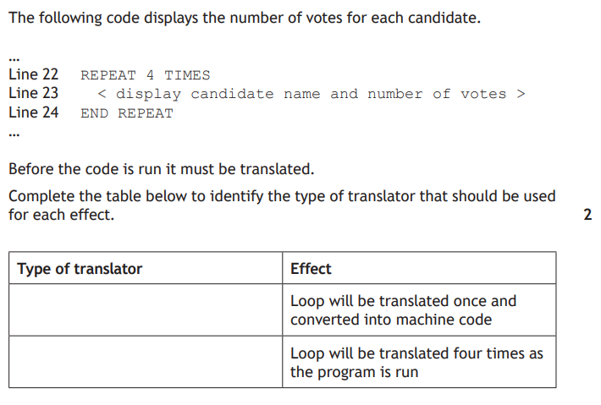

|  |  |
| --- | --- |
| **Type of translator** | **Effect** |
| Complier | Loop will be translated once and converted into machine code |
| Interpreter | Loop will be translated four times as the program is run |

**Q2.**

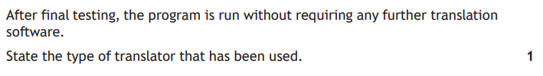

|  |
| --- |
| **Compiler** |

**Q3.**

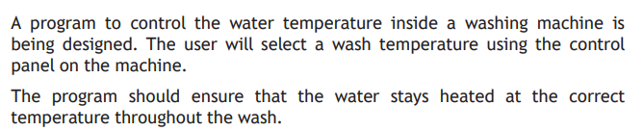

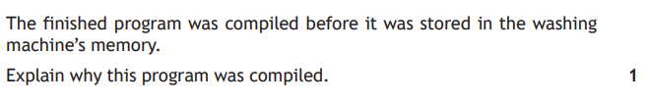

|  |
| --- |
| So that the program is processed all at once to improve speed |

**Q4.**

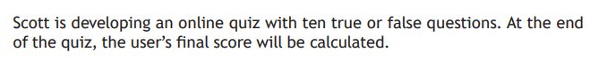



|  |
| --- |
| So that the source code is not visible to the user to change their score |